EXP 1:
#include <stdio.h>
#include <string.h>

int main() {
char s[100];
scanf("%s", s);

int n = strlen(s);

if (n > 0 && s[0] == 'a' && s[n - 1] == 'a')
printf("Accepted");
else
printf("Rejected");

return 0;
}
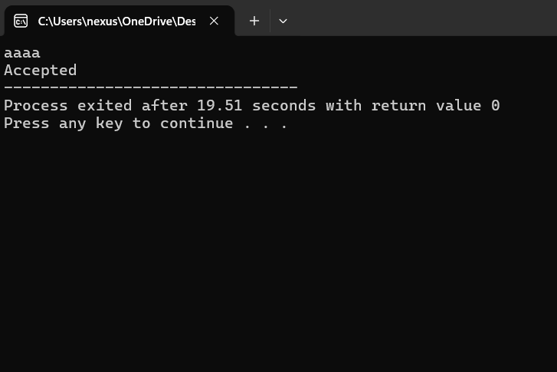

EXP 2:
#include <stdio.h>
#include <string.h>

int main() {
char s[100];
scanf("%s", s);

int n = strlen(s);

if (n > 0 && s[0] == '0' && s[n - 1] == '1')
printf("Accepted");
else
printf("Rejected");

return 0;
}
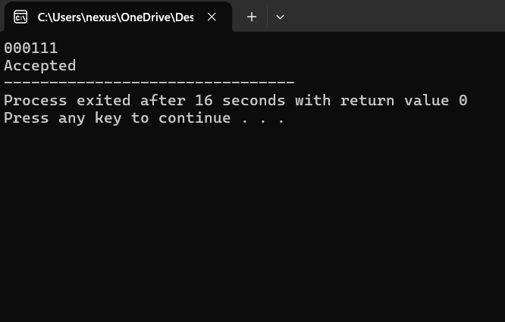

EXP 3:
#include <stdio.h>
#include <string.h>

int main() {
char s[100];
scanf("%s", s);

int n = strlen(s);

if (n >= 2 && s[0] == '0' && s[n - 1] == '1')
printf("Accepted");
else
printf("Rejected");

return 0;
}
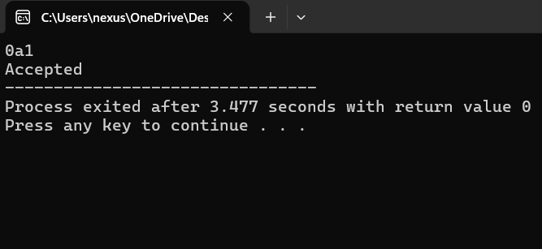

EXP 4:
#include <stdio.h>
#include <string.h>

int isPalindrome(char s[]) {
int i = 0, j = strlen(s) - 1;
while (i < j) {
if (s[i] != s[j])
return 0;
i++;
j--;
}
return 1;
}

int main() {
char s[100];
scanf("%s", s);

if (isPalindrome(s))
printf("Accepted");
else
printf("Rejected");

return 0;
}
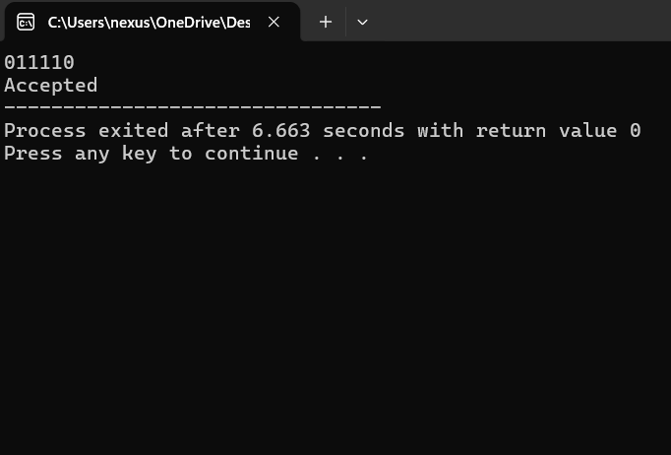

EXP 5:
#include <stdio.h>
#include <string.h>

int main() {
char s[100];
scanf("%s", s);

int i = 0, j = strlen(s) - 1;

while (i < j && s[i] == '0' && s[j] == '0') {
i++;
j--;
}

while (i <= j && s[i] == '1') {
i++;
}

if (i > j)
printf("Accepted");
else
printf("Rejected");

return 0;
}
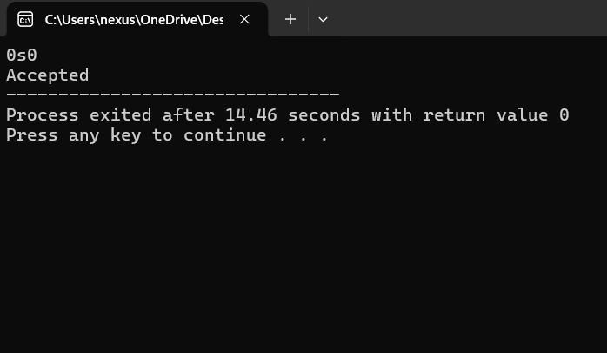

EXP 6:
#include <stdio.h>
#include <string.h>

int main() {
char s[100];
scanf("%s", s);

int i = 0, j = strlen(s) - 1;

while (i < j && s[i] == '0' && s[j] == '1') {
i++;
j--;
}

if (i > j)
printf("Accepted");
else
printf("Rejected");

return 0;
}
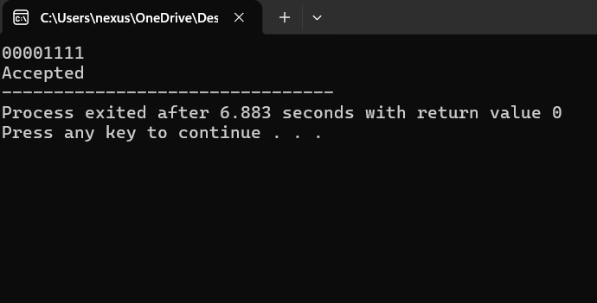

EXP 7:
#include <stdio.h>
#include <string.h>

int main() {
char s[100];
scanf("%s", s);

int n = strlen(s);

if (n >= 3 && strstr(s, "101") != NULL)
printf("Accepted");
else
printf("Rejected");

return 0;
}

